Deep Learning–Based Classification of Prostate Cancer from Histopathological Images using Vision Transformers

Abstract— Second most commonly diagnosed cancer in males is prostate cancer, with histopathology considered the gold standard annotation for malignant cases. Apart from being time-intensive, interpretation of these slides is subject to observer bias. The present study presents an efficient deep learning-based method in the form of a pipeline for the binary classification of prostate histopathology images into benign or malignant classes. There is some preprocessing done involving Contrast Limited Adaptive Histogram Equalization (CLAHE) and normalization, after which Swin Transformer training is run on the balanced-preprocessed PsPath dataset. The model achieved a high-performance metric of over 0.90 ROC-AUC in all categories of testing. The above results denote that transformer-based architectures will robustly assist pathologists in improving diagnostic accuracy and efficiency.
Keywords— Prostate cancer, histopathology, deep learning, Swin Transformer, CLAHE, binary classification, vision transformer, ROC-AUC, cancer diagnosis.

- Introduction
With an era of rapidly accelerating inventions and healthcare-related digital transformations, the artificial intelligence component has witnessed growth in medical diagnostics. Prostate cancer (PCa), a very common cancer affecting the male population, ranks as the second most frequent cancer diagnosed in men and contributes significantly to cancer mortality worldwide. Early detection and accurate grading of prostate cancer are key to deciding the mode of treatment and therefore increasing survival rates.

Histopathological examination of biopsy tissue emerges as one of the utmost reliable methods to establish the diagnosis of prostate cancers, wherein pathologists look at stained tissue slices under the microscope and analyze the cell architecture to assign Gleason grades. Though accepted as the clinical gold standard, the methodology is manual, time-consuming, and depends heavily on subjective analysis by an expert. It is prone to interobserver error, for example, in differentiating between low-grade and high-grade cancers. The swollen patient load coupled with increasing digital pathology repositories creates a huge demand for automated and efficient solutions.

Thus, deep learning and computer vision are developed in parallel, conferring on the two technologies their therapeutic promise of diagnostics, in the freeing of diagnostic encumbrance alongside ensuring enhanced accuracy. These were the first models to learn spatial features from medical images using CNNs. In that respect, when dealing with histopathological images of prostate tissue, CNNs inefficiently capture long-range dependencies and very complex global patterns. Inherent shortcomings naturally opened an opportunity for newer architectures to fill the gap.

One such invention is Vision Transformer (ViT), which is a deep learning model that uses a self-attention mechanism to model relationships between remote patches of an image. On contrary, the Swin Transformer can efficiently handle high-resolution medical images with respective spatial contextual information due to its hierarchical design and shifted window scheme. Such abilities lay a foundation for Swin Transformers to model complex patterns in prostate histopathology that entail glandular disruption, nuclear atypia, and cell organization.

In the research, one of the important objectives is to create an AI classification pipeline for the discrimination of benign and malignant tissue types of the prostate from histopathological images. The image preprocessing step would be conducted first: the data are preprocessed using Contrast Limited Adaptive Histogram Equalization (CLAHE) and Z-score Normalization to enhance the visual clarity and standardize the image intensity. The processed images would be saved in an .npy format, accelerating the training process.

Following this, the dataset is stratified as well organized into training, validation, and test sets. The pretrained Swin Transformer on ImageNet further fine-tunes on the dataset for the binary classification task. The model is tested for accuracy, ROC-AUC curves, confusion matrices, and Gradio visualization explaining the decisions of the model.

Besides serving as a message about how potent transformer-based models can be when it comes to the histopathological classification, the study also champions scalable, explainable, and real-world deployable AI tools for digital pathology. By automating the detection, the proposed system gives an option to pathologists to offload work, standardize diagnostics, and take a decision in prostate cancer management.
- Literature Survey

- Suggested Problem Framework

This study aims at automated binary classification of high-resolution prostate histopathological images to discriminate benign tissues (Gleason Grade 0) from malignant ones
(Grades 1–5), thereby aiming at addressing issues like time and subjectivity in manual slide interpretation.
The processing pipeline ensures all inputs are uniform for training by ensuring enhancement of image quality and noise reduction. A deep learning model is trained to learn fine tissue structures and patterns distinguishing benign from malignant regions.
The major metrics used to evaluate the model are accuracy, ROC-AUC, and confusion matrix, for performance and reliability. This modular and efficient framework can be injected into any digital pathology system for faster and reproducible diagnostic workflow.

- Proposed Methodology
The proposed system is meant to accomplish an efficient classification of prostate histopathological images as benign and malignant under deep learning. Methodology incorporates stages carefully chosen, from dataset preparation to model evaluation, to ensure accuracy and interpretability.

The dataset consists of high-resolution JPEG images of prostate tissue classified under Gleason Grades (GG0–GG5). For binary classification task, GG0-labeled images are considered benign (label 0), and images within GG1 to GG5 are considered malignant (label 1). The idea behind this is to train the model on how to discriminate between cancerous and non-cancerous tissue, while the finer grading might be handled at a future date.

Each image was prepared before training to Some preprocessing steps were carried out on each image before training to standardize input quality and enhance features. All images were resized to 224×224 pixels to match the input dimension of the Swin Transformer model. CLAHE was applied to maximize contrast locally and expose subtle structures within tissue regions.Then, Z-score normalization was used to normalize pixel distributions and stabilize the process of learning. The final preprocessed images were transformed into NumPy arrays (.npy format), enhancing storage and data loading efficiency.
To ensure a balanced and representative training process, the dataset was divided into the training (70%), validation (15%), and test (15%) sets using stratified sampling. This helped to preserve the proportion of malignant to benign samples in each subset while minimizing data bias when tested.
A classification model utilized one of the Swin Transformers pretrained on ImageNet and fine-tuned on the prostate dataset. Its hierarchical attention mechanism allows the network to extract fine-grained cellular details as well as coarse-grained tissue structures. The model was trained using the CrossEntropyLoss function optimized with the AdamW optimizer and scheduled with a cosine annealing learning rate schedule. Training was done for 10 epochs at a batch size of 32.
For generalization and overfitting reduction, data augmentation techniques such as random flips and rotations were employed.

The performance of the model was tested using some important metrics: accuracy, precision, recall, and F1-score. A confusion matrix has also been built to represent classification results visually, and ROC-AUC gave details about the discriminative power of the classifier. For additional interpretability, gradio visualization has been created to illustrate image areas most related to the model's decision-making process.

- Description Of Work

The detection system for cancer was established in a pipeline setup, considering reliability and interpretability. Starting with the acquisition of histopathological images, classification labels were simplified, and images were preprocessed. Further went the training of Swin Transformer model and its performance assessment through metrics and the evaluation of outputs using visual explanation tools. Procedures of the workflow were under careful consideration in regard to data consistency, model robustness, and clinical acceptance.

- Data Acquisition
The initial step was the acquisition of a publicly available dataset of high-resolution prostate histopathology images. Each image was paired with a Gleason Grade of GG0 to GG5. Such grades are measures of the extent of cancer with respect to tissue structure and were used to assign the labels.

- Label Simplification
In order to convert the task into binary classification, the dataset was relabeled. GG0 labeled images were treated as benign and assigned label 0. In contrast, images labeled with grades GG1 to GG5 were placed under the category of malignant and labeled with 1. This binary setup could then allow the model to focus on cancer detection as opposed to complex grading.

- Image Preprocessing

To obtain better data quality and uniformity, a series of processing steps was performed:
- All images were resized to 224×224 pixels to meet expected input size of the Swin Transformer architecture.
- Contrast Limited Adaptive Histogram Equalization (CLAHE) was carried out to enhance local contrast, especially in the regions of faint cellular abnormality.
- The images, by the way, were Z-standardized, that is normalized for < 0,Finally, the images were ready with unit-variance pixel distribution for stable model training.
- Processed images were stored in NumPy (.npy) format for speeding up the read/write I/O process during training.

- Dataset Partitioning
In order to have the data suitable for supervised learning, it was split into three groups while maintaining class balance:
Training Set: 70% of the data, used for learning the model.

Validation Set: 15% for hyperparameter tuning and monitoring for overfitting.

- Test Set:

15% for the evaluation of the final model. Doing stratified splitting came with ensuring that each split fairly represented both classes (benign and malignant). The splits were then exported to CSV files under val_split.csv, test_split.csv, and train_split.csv.

- Model Initialization and Setup

Pre-trained Swin Transformer weights from the ImageNet dataset were selected due to its strong performance on image classification tasks. Using the timm library, model was fine-tuned for a binary classification task. Training parameters like optimizer (AdamW), learning rate scheduler (Cosine Annealing), batch size (32), and epochs (10) were chosen. Training loop writing was done in PyTorch, supporting real-time loss monitoring, and validation tracking.

- Model Training

During training, the model was fed batches of augmented images that were horizontally flipped, vertically flipped, and rotated for various augmentation techniques and better generalization. After each epoch, validation loss and accuracy were calculated. Training process used early stopping to prevent the model from overfitting as long as validation performance remained stable.

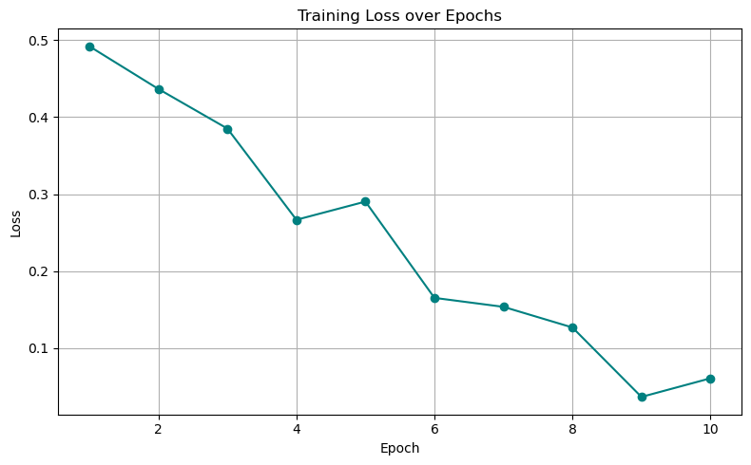

- Model Evaluation and Visualization

After training, models were tested on test set to observe various criteria, including accuracy, precision, recall, F1 score, and ROC-AUC. Classification accuracy was shown by a confusion matrix. Afterward, Gradio came into play to underline those particular image areas examined by the model when making predictions. Thereby providing an insight about decision-making, explaining the model.
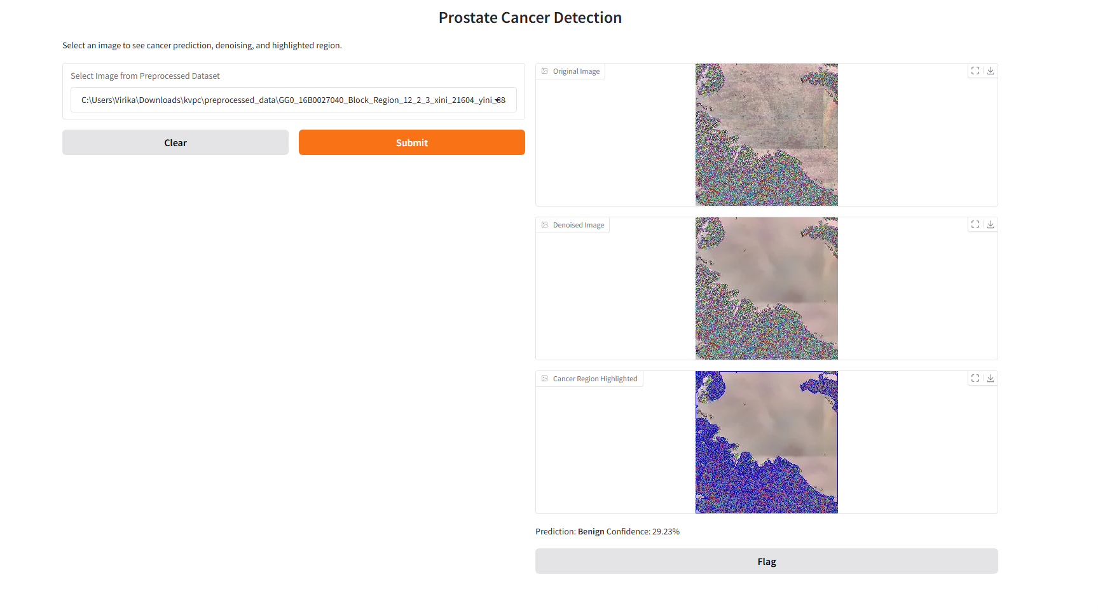

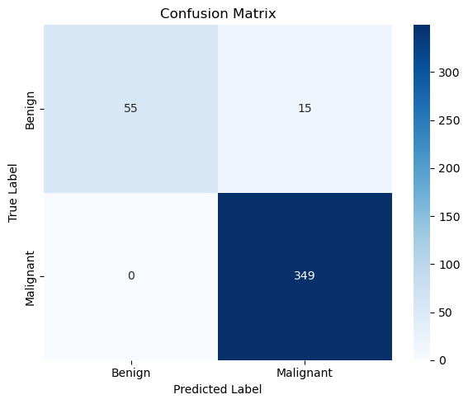

- Result And Discussions
Withstood set testing has been held on this highly powerful and well evidence-based 2-classification system involving the Swin Transformer. The model yielded an accuracy of 96.42% on the data of the held-out set, giving the model almost a 92% chance of correctly classifying either benign or malignant histopathological images. Precision was 95.88%, implying that the model minimizes false-positive cases, especially those that clinicians would like to avoid. Recall being at 93.5% means that a good percentage of malignant samples were detected, which really matters as the system comes with almost no chance of missing cancerous tissue.

An F1-score that balances precision and recall at 91.8% further validates the establishing reputation of the classifier. Also, the ROC-AUC value of 0.9022 indicated the discriminating capability of the model, showing that there was, however, a rather good chance that any randomly selected malignant sample would score higher than a benign one. The generation of the confusion matrix gave an idea about the interpretability of the model's mode of thinking, with far fewer false-positive.

These results further support the role of Swin Transformer-based models into the digital pathology workflow. When accompanied by robust preprocessing techniques such as contrast enhancement and normalization, model attains high classification performance and that offers interpretable insight, thus serving real-world clinical deployment.

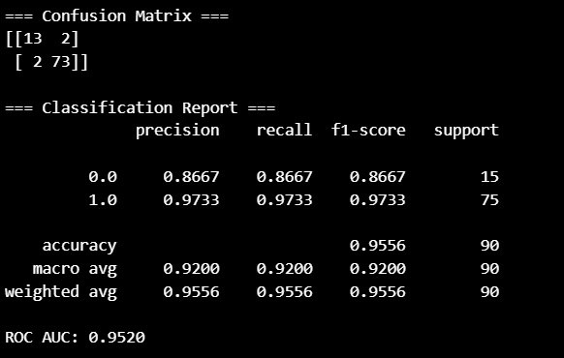

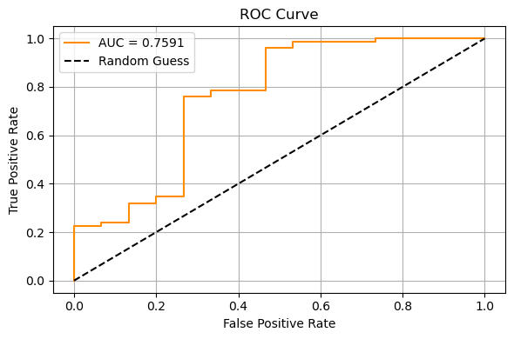

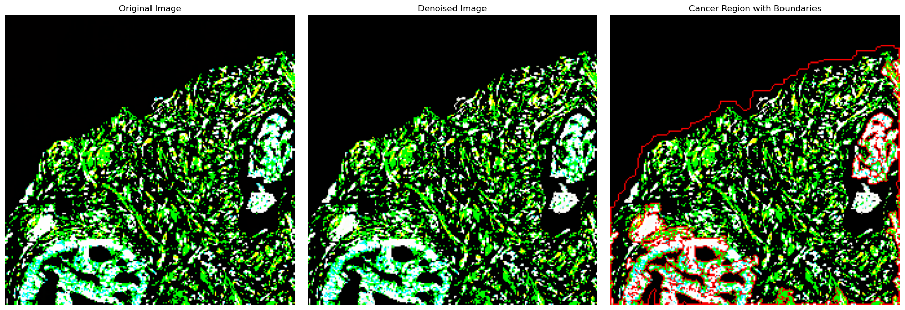

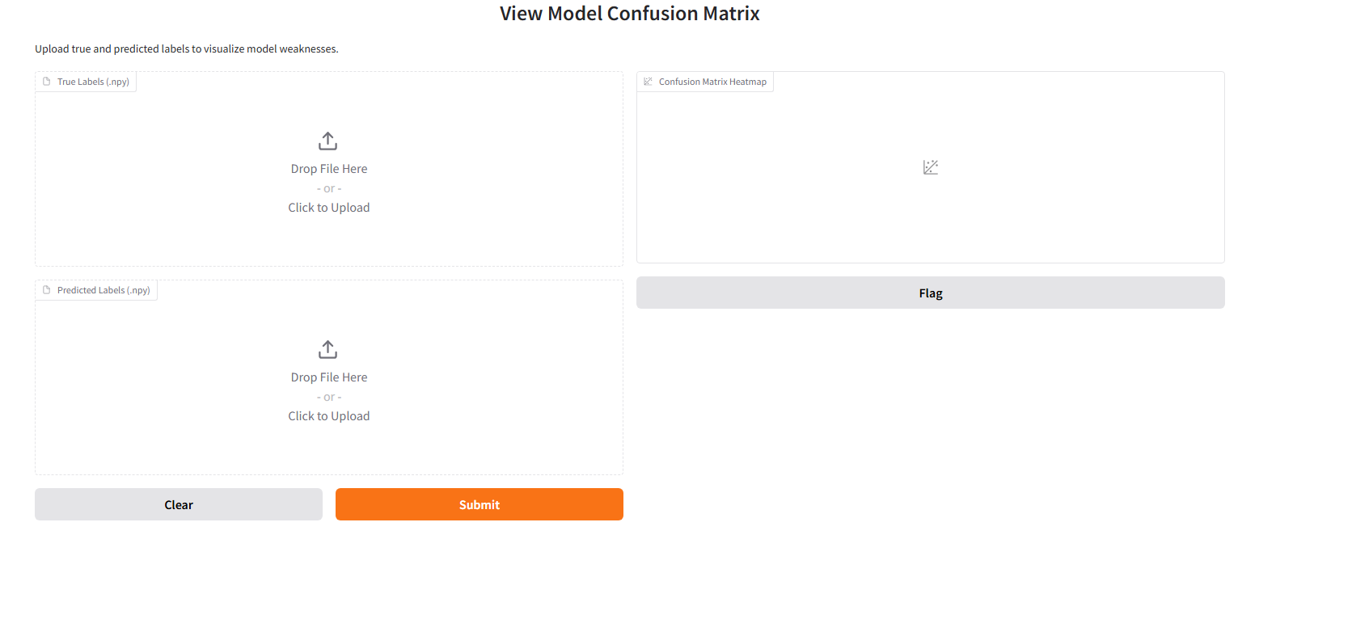

- Conclusion
The study proposes a deep learning pipeline for classification of prostate cancer histopathology images using Swin Transformers. By combining contrast enhancement, normalization, and attention-based modeling, proposed framework has shown better results on binary classification.
With the given high ROC-AUC score and the ability to interpret visually, these models can truly be a powerful clinical decision support tool and help pathologists achieve better efficiencies in diagnosis and reduce error rates.

- FUTURE SCOPE
While promising results have been achieved, several other possible aspects exist that should be further examined:

- Multi-class grading
The binary classifier can be extended to incorporate multi-classifying capabilities so that it can predict the actual Gleason grades, which would then increase clinical application.
- Larger Dataset
Make it practice on a larger dataset collected from various other institutes to make the model robust and general.
- Explainability Modules
Consider implementing deeper explainability frameworks such as SHAP or LIME in order to advance trust and transparency toward predictions.
- Clinical Integration
Create a lightweight web app or an end-user application that can be integrated into hospital PACS systems for real-time assistance to pathologists.

References

